AI-STORYGENERATOR

REPORT OF PROJECT

SUBMITTED IN PARTIAL FULFILLMENT OF THE REQUIREMENT FOR THE AWARD OF THE DEGREE OF

BACHELOR OF TECHNOLOGY

IN

COMPUTER SCIENCE & ARTIFICIAL INTELLIGENCE

Batch


(2022-2026)

SUBMITTED BY SUPERVISED BY
Rupam Priya Dr. Ridhi Kapoor
12200791

DEPARTMENT OF COMPUTER SCIENCE AND ENGINEERING DAV UNIVERSITY JALANDHAR-PUNJAB144012 JALANDHAR -144001, PUNJAB
ACKNOWLEDGMENT

I would like to express my sincere gratitude to my project guide, Dr. Ridhi Kapoor, for their valuable guidance, constructive feedback, and continuous support throughout the duration of this project. I am also thankful to Dr. Rahul Hans and the Department of Computer Science and Artificial Intelligence for providing the necessary resources and an encouraging academic environment.

My appreciation extends to all faculty members and classmates whose suggestions and cooperation helped strengthen the quality of this work. Lastly, I am deeply grateful to my family for their constant encouragement and support, which motivated me to complete this project successfully.

DECLARATION

I, Rupam Priya, hereby declare that the work which is being presented in this project titled “AI-BASED STORYGENERATOR” by me, in partial fulfilment of the requirements for the award of Bachelor of Technology (B. Tech) Degree in “Computer Science and Artificial Intelligence” is an authentic record of my own work carried out under the guidance of Dr. Ridhi Kapoor.

To the best of my knowledge, the matter embodied in this report has not been submitted to any other University/ Institute for the award of any degree or diploma.

Rupam Priya
12200791

ABSTRACT

This project presents an end-to-end system that transforms a short textual idea into a coherent, multi-scene story accompanied by AI-generated illustrations for each scene. Designed for writers, educators, students, and creative professionals, the system automates the two traditionally separate tasks of narrative creation and illustration. A single user input (1–2 line prompt) is expanded into a structured story (introduction, conflict, climax, resolution), scene descriptions are extracted, and each scene is rendered into an illustration using state-of-the-art text-to-image models. The final output is an editable, exportable storybook (PDF or gallery) that supports multiple genres, tones, and art styles.

Table of Content
Sr No. | Content | Page No.
1. | Introduction | 6-8
2. | Title of the Project | 9-11
3. | Objectives | 12-14
4. | Steps to Achieve the Objectives | 15-18
5. | Coding and Implementation | 19-24
6. | Conclusion and Recommendation | 26-27
7. | References | 28

Chapter-01 Introduction
Storytelling has always been one of the most powerful forms of human expression. From ancient cave paintings to modern digital animations, the need to communicate ideas, emotions, and imagination through stories has remained constant. However, the process of creating high-quality stories—especially those accompanied by visual illustrations—has traditionally been time-consuming and dependent on artistic skills. Writers need creativity and patience to craft narratives, while illustrators must manually design and draw visuals that match the storyline. This creates a clear gap: many students, teachers, content creators, and beginners have strong ideas, but lack the time, writing expertise, or drawing skills required to bring those ideas to life.
In recent years, Artificial Intelligence (AI) has transformed multiple industries by automating complex tasks, improving workflows, and enabling creativity at scale. With the advancement of natural language generation (NLG) models like GPT-4, GPT-5, Claude, Mistral, and LLaMA, and visual generation models like DALL·E, Stable Diffusion, and Midjourney, the process of storytelling and illustration has entered a new era. AI systems can now take a minimal human input—sometimes as short as one line—and expand it into a well-structured narrative. Similarly, text-to-image models can analyze scene descriptions and instantly produce high-quality illustrations in various art styles.
The AI-powered Text-to-Image Story Generator project aims to combine these two powerful AI capabilities into one seamless platform. The purpose of this project is to create a system that converts a short textual idea into a complete illustrated story with minimal user effort. The user only needs to enter a simple prompt, such as “A young girl finds a secret door in the attic,” and the system automatically generates a four-scene story along with visually appealing AI-generated images for each scene. The interface is designed to be simple, intuitive, and user-friendly so that even beginners with no technical knowledge can create illustrated stories with ease.
The main motivation behind the project is the difficulty many people face in converting imagination into written and visual content. Students often struggle to visualize stories for school projects. Teachers need quick story material for classroom activities. Writers and content creators require frequent inspiration and drafts. Artists may want references for their concepts. Traditional storytelling requires both writing ability and artistic skill, and both are time-intensive tasks. By integrating AI into the process, this project makes storytelling accessible, fast, and interactive for everyone.
The system is built as a full-stack application. The frontend, developed using React or similar UI frameworks like Streamlit or Gradio, allows users to enter prompts, choose preferences such as genre or tone, and view generated outputs. The backend—implemented using Node.js, Express.js, or Python Flask—handles communication between the frontend and AI models. It receives the user prompt, creates structured requests for the text generation and image generation modules, and processes the results. For text generation, the system leverages state-of-the-art large language models that transform the initial idea into a coherent story divided into scene-wise segments: introduction, conflict, climax, and resolution. For image generation, scene descriptions are converted into optimized prompts for AI image models, which then produce illustrations that visually align with the story.
The project also focuses on flexibility and customization. Users can choose genres like fantasy, horror, sci-fi, or adventure. They can define tones—funny, emotional, dark, or inspirational. They can specify target audiences such as children, teenagers, or adults. These settings allow the system to adapt the storytelling style based on user needs. In addition, users can regenerate specific images or edit parts of the story, giving them creative control over the final output. Once the story and images are ready, the system assembles them into a unified storybook layout. Export features allow users to download the complete story as a PDF or save the images as a gallery.
This project is not only an innovative use of AI but also a valuable educational tool. It helps students understand narrative structure, enhances creativity, and makes learning interactive. For developers, the project demonstrates how modern AI models can be integrated with web technologies to create real-world applications. For researchers, it showcases how natural language processing and text-to-image generation can be combined to produce meaningful outputs. Most importantly, it empowers individuals—regardless of writing or artistic skill—to express ideas through illustrated storytelling.
The AI-powered Text-to-Image Story Generator also reflects the growing need for accessible and fast creative tools in today’s digital world. As education, entertainment, and online content creation continue to expand, users increasingly prefer platforms that offer instant, high-quality, and personalized results. This system fulfills that need by allowing anyone—regardless of writing or artistic skill—to create visually rich stories effortlessly. Students can use it for school projects, teachers for interactive learning content, and creators for quick concept drafts or visual ideas. The tool’s flexibility, such as genre selection, tone customization, and the option to regenerate individual scenes, ensures that each output is unique and user-specific. By combining natural language generation with text-to-image models, the project demonstrates how AI can simplify complex creative workflows. As AI-assisted creativity becomes more common, this project represents a meaningful step toward the future of storytelling and digital content generation.
In the long term, the project has the potential for advanced extensions such as character consistency across scenes, text-to-speech narration, animated story generation, background music integration, and even full storyboard creation for films. These future enhancements can make the tool even more engaging and open doors to multimedia content creation.
Overall, the AI-powered Text-to-Image Story Generator stands as an example of how artificial intelligence can bridge creativity and technology. It transforms simple ideas into rich, illustrated stories within seconds, making storytelling accessible, enjoyable, and achievable for everyone. This introduction sets the foundation for the project’s structure, methodology, and implementation, demonstrating how AI can simplify and amplify human creativity.

Chapter-02 About the project

2.1 Introduction to the Background
The world of storytelling has changed rapidly over the last decade. Earlier, stories were created only through writing and manual illustrations, which required time, creativity, and artistic skills. But today, Artificial Intelligence has opened new doors for creativity. With AI, even a simple one-line idea can become a complete, illustrated story within seconds.
This project is built on the idea of combining creativity + technology to make storytelling easier, faster, and more enjoyable for everyone—students, teachers, writers, and content creators.
2.2 Why This Project Was Needed
1. Traditional storytelling challenges
- Writing a structured story takes time.
- Every person is not good at creating stories.
- Illustrations require artistic skills or professional designers.
- Students often struggle to imagine scenes visually.
- Teachers need quick story material for classroom activities.

2. Modern digital needs
- Education and entertainment are moving online.
- Users expect quick, high-quality, personalized content.
- AI tools are becoming essential in creative fields.
- Digital storytelling has become a part of learning and communication.
This project fills all these gaps.
2.3 The Idea Behind the Project
The simple idea was:
“Can a computer take a small idea and turn it into a complete illustrated story?”
To make this possible, two powerful AI branches were combined:

1. Natural Language Generation (NLG)
Used to write the story from a one-line prompt.

2. Text-to-Image Generation
Used to visually illustrate each scene.
Together, these two create a magic-like experience where AI becomes your writer and illustrator.
2.4 How AI Improves Storytelling
AI transforms storytelling in several creative ways:
- Turns short ideas into detailed stories.
- Maintains a proper story structure (introduction, conflict, climax, ending).
- Generates unique images for each scene.
- Offers multiple art styles (anime, realistic, watercolor, 3D, etc.).
- Makes the process fun, interactive, and beginner-friendly.

2.5 Real-World Inspiration
This project is inspired by:Students - who need easy visualization for school projects.
Teachers - who want ready-made, illustrated content for lesson plans.
Content Creators - who need fast storyboards for videos or scripts.
Writers-who need instant idea expansion and visual references.
Kids - who love imagining stories but can’t draw or write them perfectly.

2.6 Why AI Was the Perfect Choice
AI is ideal for this project because:
- It works fast and gives instant results.
- It generates creative storylines beyond human imagination.
- It can produce multiple versions of the same story.
- It maintains consistency, clarity, and structure.
- It makes storytelling accessible for everyone—no skills required.
2.7 How This Project Stands Out
This project is not just a tool; it is a complete storytelling experience because it:
- Accepts simple natural language input
- Produces structured story modules
- Generates images automatically
- Allows editing and regeneration
- Supports export to PDF storybooks
- Blends creativity with advanced AI technologies
2.8 Educational Value of the Project
Teachers and students will find this system extremely helpful. It:
- Improves imagination and creativity
- Helps understand story structure
- Makes learning fun through visuals
- Encourages students who struggle with writing
- Supports project-based learning

Chapter- 03 Objectives
3.1 Primary Objectives
The primary objectives focus on the main purpose of the AI-powered Text-to-Image Story Generator. These objectives define the core functionalities that the system must achieve:
- To automatically generate a complete story from a short user prompt using Natural Language Generation (NLG) models.
- To create scene-wise illustrations using text-to-image AI models like DALL·E or Stable Diffusion, ensuring each scene has a relevant visual representation.
- To integrate story generation and image generation into a single seamless workflow where the system processes the prompt and produces a full illustrated output.
- To ensure narrative structure and coherence, maintaining a proper flow from introduction to conclusion.
- To build a user-friendly interface that allows users of all ages to easily input prompts, view results, and navigate the system without technical difficulty.
3.2 Secondary Objectives
Secondary objectives focus on improving usability, enhancing creativity, and providing additional features that make the project more practical:
- To offer customization options, such as selecting genre, tone, art style, and target audience.
- To allow regeneration and editing of specific scenes or images for better control and personalization.
- To support export features, enabling users to download the entire illustrated story as a PDF or save images separately.
- To make the system educational, helping students, teachers, and beginners visualize stories and improve creativity.
- To demonstrate full-stack AI implementation, combining frontend, backend, APIs, and AI models into one integrated application.
- To design the system so it can be expanded in the future with advanced features like voice narration, animation, or character consistency.
3.3 Problem-Solving Approach
The project follows a structured problem-solving approach to convert complex tasks—story writing and illustration—into an automated AI-driven process:
- Identification of the problem:
Creating stories manually takes time, and generating illustrations requires artistic skills. Many users struggle with imagination and structuring content.
- Breakdown of tasks:
The problem was divided into smaller components—story generation, scene extraction, image creation, and assembling the output.
- Use of AI models:
NLG models were selected to write stories, while text-to-image models were chosen to generate illustrations. This reduces human effort and increases accuracy.
- Designing a workflow:
A step-by-step pipeline was created where the system:
  - Takes user input
  - Expands it into a story
  - Extracts visual prompts
  - Generates images
  - Combines everything into a final illustrated output
- Frontend and backend integration:
The UI collects input, the backend processes it, and AI models generate output. Smooth communication ensures fast results.
- Testing and refinement:
Several prompts were tested to improve story quality, image accuracy, and user experience, ensuring the final system works reliably.

Chapter - 04 Steps to Achieve Objectives
4.1 System Design Approach
The system design approach focuses on combining AI models, backend logic, and a user-friendly frontend to achieve the project’s objectives effectively. The key design principles used are:
- Modular Design:
The entire system is divided into clear modules—Input Module, Story Generation Module, Image Generation Module, and Output Display Module. Each module performs a specific function, making the system easier to develop and maintain.
- Client–Server Architecture:
The frontend handles user interaction, while the backend processes story generation, image creation, and API communication. This separation ensures smooth workflow and better scalability.
- AI-Centric Processing:
Both NLG (text generation) and text-to-image models are integrated into the backend. These models form the core engine responsible for converting user prompts into story and visuals.
- Customization Support:
The UI is designed to accept various user preferences such as genre, tone, and art style. This ensures flexibility and personalized output.
- Performance Optimization:
Efficient API calls, caching strategies, and optimized prompts help reduce response time and improve user experience.
4.2 Workflow Methodology
The workflow methodology explains how an idea given by the user travels through the system and becomes a fully illustrated story. The steps include:
Step 1: User Input
- User enters a short idea (1–2 lines).
- Optional settings like genre, tone, and art style are selected.
Step 2: Story Expansion
- Backend creates a structured prompt for the text generation AI model.
- The model generates a four-scene story:
Introduction → Conflict → Climax → Resolution
Step 3: Scene Extraction
- Each scene is analyzed to identify its key visual elements.
- These elements are converted into short image prompts.
Step 4: Image Generation
- Text-to-image model (DALL·E, Stable Diffusion, etc.) receives scene prompts.
- High-quality illustrations are produced for each scene.
Step 5: Output Assembly
- The frontend displays every scene with its story text and corresponding image.
- Users can regenerate text or images if needed.
Step 6: Exporting
- Users can download the final storybook as a PDF or export all images.
- A shareable link may also be generated.
This workflow ensures clarity, automation, and smooth user experience.
4.3 Architecture Diagram
Below is the textual explanation of the system architecture (you can draw the diagram in your file based on this description):
+-----------------------+
| Frontend |
| (React/Gradio UI) |
+-----------+-----------+
|
| User Prompt + Settings
v
+-------------+-------------+
| Backend |
| (Node.js / Flask Server) |
+-------------+-------------+
|
+---------------+----------------+
| |
v v
+-------------+ +------------------+
| Story Gen | | Image Generator |
| AI Model | | (DALL·E/SD) |
| (GPT/LLAMA) | +------------------+
+-------------+ |
| |
| Scene Texts | Scene Images
+---------------+------------------+
v
+-----------------------------+
| Output Assembler |
| (Story + Images Combined) |
+--------------+--------------+
|
v
Final Illustrated Story
Explanation:
- The frontend sends user inputs to the backend.
- The backend calls the text model to generate the story.
- Scene summaries are sent to the image generator.
- Everything is combined and displayed to the user.
4.4 Development Phases
The development of the project was carried out in multiple well-defined phases:
Phase 1: Requirement Analysis
- Identifying the need for automatic story + image generation.
- Understanding user requirements like customization, export options, etc.
Phase 2: System Planning
- Deciding technologies for frontend, backend, and AI integration.
- Choosing models for text generation and image creation.
Phase 3: Designing Modules
- Designing UI components for input and output.
- Creating backend routes for story and image generation.
- Planning data flow between components.
Phase 4: AI Integration
- Integrating GPT-based text model for story generation.
- Adding DALL·E/Stable Diffusion APIs for image creation.
- Testing prompt engineering for accuracy.
Phase 5: Frontend Development
- Building the user interface using React/Gradio.
- Designing input forms, story display components, and export buttons.
Phase 6: Backend Development
- Creating API endpoints for text and image requests.
- Handling authentication, communication, and data processing.
Phase 7: Testing & Debugging
- Checking story quality, image relevance, and workflow accuracy.
- Fixing errors in prompts, API calls, UI layout, and rendering.
Phase 8: Final Integration & Deployment
- Combining all modules.
- Deploying the project so users can access the tool online.

Chapter-05 Codes and Implementation

5.1 Implementation Overview
The entire system works using four major layers:
1. UI Layer (React + TS Components)
Responsible for user input, selecting genre/tone/style, and displaying the generated story.
2. Logic Layer (Custom Hooks)
Handles API calls, loading states, and error handling.
3. API + Backend Layer (Next.js API Routes)
Connects to AI services, processes prompts, and returns results.
4. AI Integration Layer
Uses GPT models for story text and DALL·E / Stable Diffusion for images.

5.2 UI Layer Implementation
Your components/ui/ folder contains reusable components like:
- Slider
- Switch
- Tabs
- Textarea
- Toast
- Tooltip
- Toggle
These are used to build a clean and interactive interface.
StoryGenerator.tsx (Main UI Module)
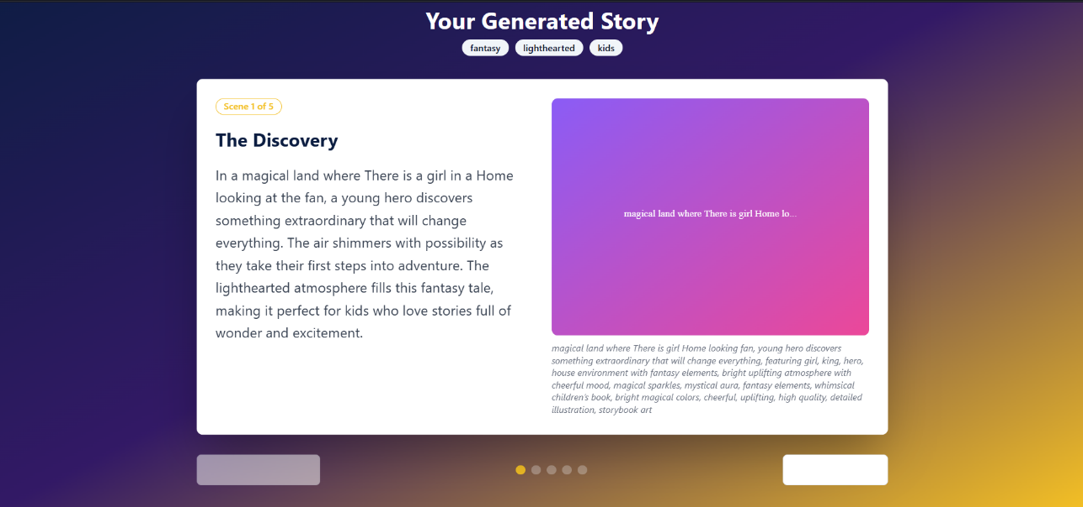
This component is the heart of the frontend. It performs:
- Taking user input (story idea)
- Selecting story genre, tone & art style
- Sending request to backend
- Displaying generated story scenes
- Showing AI-generated images for each scene
This component binds together all UI elements and logic hooks.
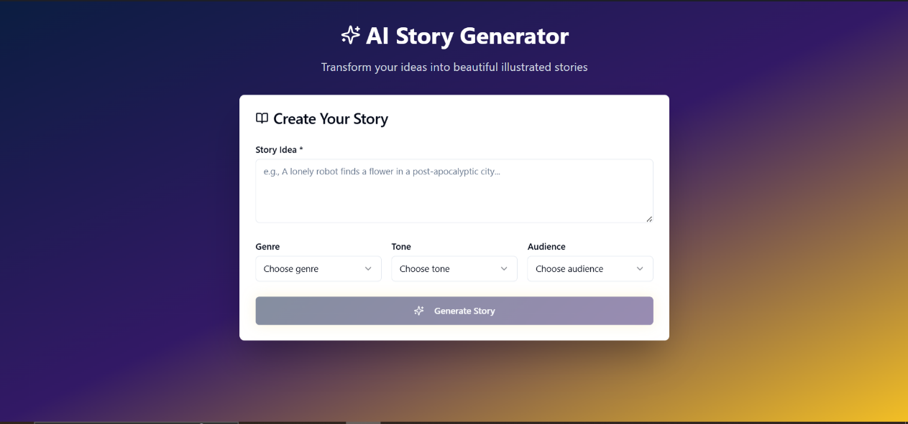

5.3 Logic Layer Implementation – Custom Hooks
The hooks/ folder simplifies backend logic.
useImageGeneration.ts
This hook is responsible for:
- Calling the /api/image-generation route
- Passing scene prompt + art style
- Managing loading states (spinners)
- Handling errors (via toast notifications)
- Returning image URL to StoryGenerator component
By keeping logic in hooks, the UI remains clean and easy to manage.
use-toast.ts & use-mobile.ts
These support UI behavior:
- use-toast.ts → shows success or error popups
- use-mobile.ts → handles mobile responsiveness
This modularization improves readability and reusability.
5.4 Backend Implementation – API Routes
The pages/api/ folder contains backend logic.
image-generation.ts
This file works as:
- A server-side API route
- Takes user’s scene text and art style
- Sends it to AI image generation model (e.g., DALL·E, Stable Diffusion)
- Receives generated image URL or base64
- Returns it to the frontend
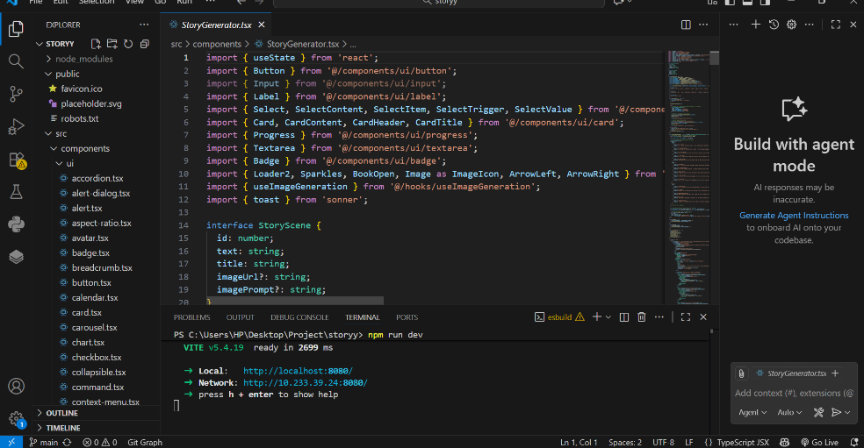
This ensures your API keys remain safe and never exposed to the client.
Backend tasks include:
- Prompt engineering
- Error handling
- Secure communication with external models
- Formatting the final JSON response
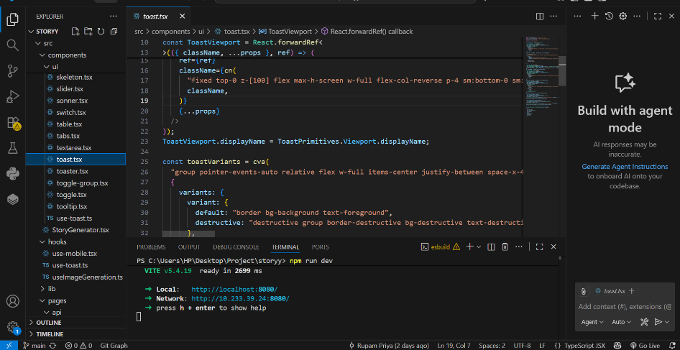
This route is essential for image generation.
5.5 Story Generation Logic
Although not shown in the screenshot, the NLG (story generation) usually happens in:
- pages/api/story-generation.ts (or inside the same image route depending on your setup)
- Or directly inside the backend using GPT models
The story engine:
- Takes the main user idea
- Converts it into 4-scene structured story
- Extracts key visual elements for each scene
- Prepares image hints for the image generation hook
This ensures every scene has consistency and proper flow.
5.6 AI Integration Layer
The project integrates AI in two steps:
1. Text Generation (Story)
Tools → GPT-4, GPT-3.5, GPT-5, Claude, Mistral, etc.
Used for:
- Creating scene titles
- Writing paragraphs
- Extracting visual cues
2. Image Generation
Tools → DALL·E, Stable Diffusion, Midjourney (API)
Used for:
- Creating scene visuals
- Applying art style (anime, 3D, watercolor, realistic)
- Ensuring image storytelling consistency
This layer makes the project a true text-to-image story generator.
5.7 Output Assembly & Rendering
Once the story and images are available:
- StoryGenerator.tsx compiles them
- Each scene is displayed in the UI with:
  - Title
  - Paragraph
  - Generated image
Users can:
- Regenerate images
- Edit story
- Download as PDF
- Save images
This completes the full storytelling cycle.
5.8 Code Quality & Best Practices Used
The project follows several coding standards:
- Component-based architecture
- Reusable UI elements
- Strong TypeScript typing
- Custom hooks for API calls
- Clean backend routing
- Secured environment variables
- Modular folder structure
- Clear separation of UI and logic
This ensures the project is professional and maintainable.

Chapter-06 Conclusion and Recommendation
6.1 Conclusion
The AI-powered Text-to-Image Story Generator project successfully demonstrates how modern artificial intelligence can transform the process of storytelling. By combining Natural Language Generation (NLG) models with Text-to-Image generation models, the system is able to convert a simple 1–2 line idea into a complete, illustrated story. This makes the storytelling experience faster, more interactive, and accessible to people who may not have strong writing or drawing skills.
The project achieves its main goal of automating two traditionally time-consuming tasks:
- Story Writing:
AI models generate a structured story with clear scenes, coherence, and narrative flow.
- Image Creation:
Visual illustrations are created automatically for each scene using advanced text-to-image models.
Through the frontend interface, users can customise genres, tones, and art styles, making the experience personal and creative. The backend routes efficiently handle AI integration, prompt processing, and secure communication, ensuring the system works smoothly and reliably.
This project demonstrates how AI can be used in practical real-world applications such as education, creative writing, content creation, digital storytelling, and learning support. It also provides a foundation for future enhancements like animated stories, voice narration, and storyboard generation.
Overall, the project is a step toward redefining how humans interact with creativity and imagination using emerging AI technologies.

6.2 Recommendations
While the system performs well in generating illustrated stories, there are several ways it can be improved and enhanced in the future. The following recommendations will help increase the project’s effectiveness, usability, and scalability:
1. Enhance Character Consistency
AI-generated images may not always maintain consistent character appearance across scenes.
Using advanced AI models or fine-tuned diffusion models could help ensure that characters look the same throughout the story.
2. Add a Dedicated Story Generation API
Currently, story generation may be handled within a single route. Creating a dedicated /api/story-generation endpoint will improve modularity and make the system easier to maintain or extend.
3. Improve Image Quality & Style Control
Different model settings (resolution, lighting, artistic style, color palette) can improve visual accuracy and aesthetics. Adding more style presets or sliders can give users more creative control.
4. Add Offline Storage or Cloud Database
Saving generated stories to a database would allow:
- user account creation
- viewing past stories
- sharing stories
- collaborative editing
This would make the system more robust and professional.
5. Introduce Text-to-Speech (TTS)
Adding voice narration will make the system more appealing for children, teachers, and presentations.
6. Add an Animation Mode
Allowing users to convert stories into short animated clips would significantly increase the application’s creative potential.
7. Mobile App Version
Developing a responsive mobile interface or a React Native app could improve accessibility for younger users and educators.
8. Improve Error Handling
More descriptive error messages and retry options can make the system smoother during image-generation failures.
9. Provide Multi-Language Support
Allowing users to generate stories in Hindi, English, and other languages would expand the reach of the tool.
10. Add a Storyboard Export Option
A storyboard layout would be useful for:
- filmmakers
- animators
- designers
- advertising teams

Chapter-07 References
• OpenAI. OpenAI API Documentation – Text & Image Generation.
https://platform.openai.com/docs/
• Stable Diffusion. Latent Diffusion Model Research Paper.
https://arxiv.org/abs/2112.10752
• React. Official React Documentation.
https://react.dev/
• Next.js. Next.js API Routes & Framework Guide.
https://nextjs.org/docs
• Node.js & Express. Backend Development Documentation.
https://expressjs.com/
• TypeScript. TypeScript Official Documentation.
https://www.typescriptlang.org/docs/

Github:- https://https://github.com/rupam-priya23/Rupam12200791_B49A_-2-

